

ACADEMIC YEAR 2025-26

DIBRIS
Robotics Engineering

Computer Vision
Third assignment:
Stereopsis: Eight points algorithm implementation and Image Matching

Matteo Spluga Matricola: 9185902
- Introduction
The main goal of this laboratory is firstly to implement the eight points algorithm in the case of stereo image pairs, which is an essential technique in computer vision, secondly to acquire 2 very similar images in order to perform an image matching technique on them. The eight points algorithm is primarily utilized for determining the fundamental matrix F, which describes the epipolar geometry between stereo image pairs. The image matching technique is generally used to describe similarity between image pairs. All operations were carried out using MATLAB 2023b.

- Image matching application
For this task, the local matching technique was used in order to extract local features described by a subset of pixels (sparse correspondences). Moreover, it was asked to take our own pictures which have a high level of similarity (a small translation and rotation) . Considering the fact that the two images have a high level of similarity, the use of image patches are an appropriate feature description. By this it is meant that no broad translations, marked illumination changes, scale differences or even deformations can be found on the two images. The task was performed by using algorithms which picked some points of the first image (“robotView1.jpg”) and computed the similarity between them and every other point of the second image (“robotView2.jpg”) in order to find the most similar one. This was done by using patches surrounding the points of interest.
In the “imageMatching.m” file is contained a function (which is later put in the main file) which computes the correspondences between the two images. This is also done by calling a function from the “findMatches.m” file. In the latter, the task is performed in four steps:
- Extracting interest points with FAST and descriptors with SURF (discarding points close to the borders);
- Constructing the similarity matrix A(i,j) with POSNCC (combination of the position between points and patch correlation around them).
- By applying, if withSVD = 1, an SVD decomposition to emphasize the more consistent correspondences.
- By checking, for each chosen point of the first image, if the j value of the maximum similarity on the image 2 has the same point as the best correspondence. Then it checks if that value exceeds the selected threshold.
All the valid matches are saved in “list”. A threshold of 0.65 and a sigma of 100 has been used to find the matching points. The threshold is chosen to have a sufficient number of points (not too few but not even too many) in order to have more reliable points. If a very small value had been chosen, a greater amount of matches would have been found, but considering also a lot of “fake matches”. The value of sigma is high because more distant points should be taken into account.
A delta value of 10 (regarding the patch size) has been chosen in both the matching techniques which considered the patches similarity and the Euclidean distances between positions and patches similarity. Considering the fact that the delta is half the size of the patch, by choosing a delta = 10 we obtain a 20x20 patch.

The points of interest (matching candidates found with FAST) on both images are the following (fig. 2a, 2b):

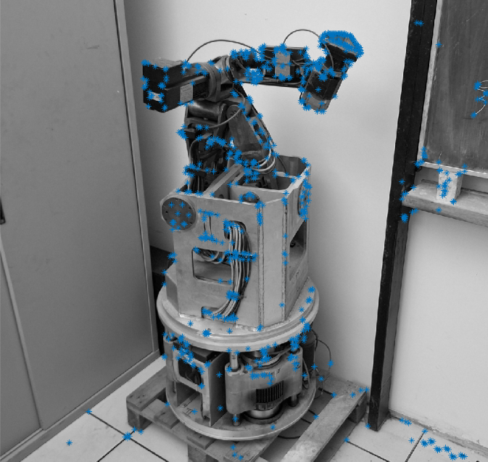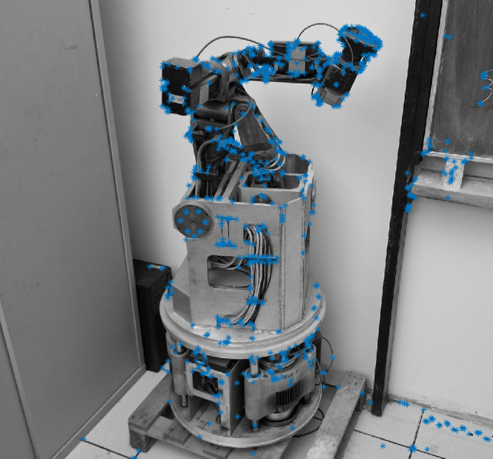
(2a) (2b)
It can also be seen the original similarity matrix (before the SVD application) in fig. 2c:

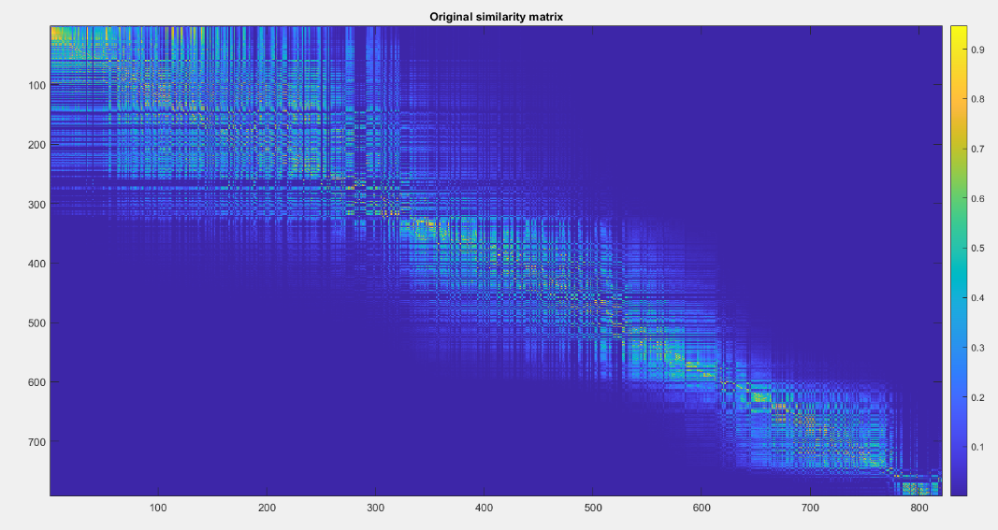
(2c)
- Rows: “robotView1.jpg” points of interest (candidates);
- Columns: “robotView2.jpg” points of interest (candidates);
Each value of the matrix checks how the “i” point of the first image is similar to the “j” point of the second image (by POSNCC and POSSURF). The original similarity matrix appears irregular, noisy, and filled with vertical and horizontal interference patterns, with clusters of high-similarity values that are not well organized. This noise is caused by several factors: many weak or accidental correspondences between visually similar patches, keypoints that do not have a true match but still yield moderate similarity scores and small imaging variations such as illumination changes or slight rotations. As a result, the diagonal structure that should represent the true correspondences between the two images is present but almost completely submerged in noise.
Then we can consider the representation of the A similarity matrix after the use of SVD to check the strong matches found by the algorithm (fig. 2d):

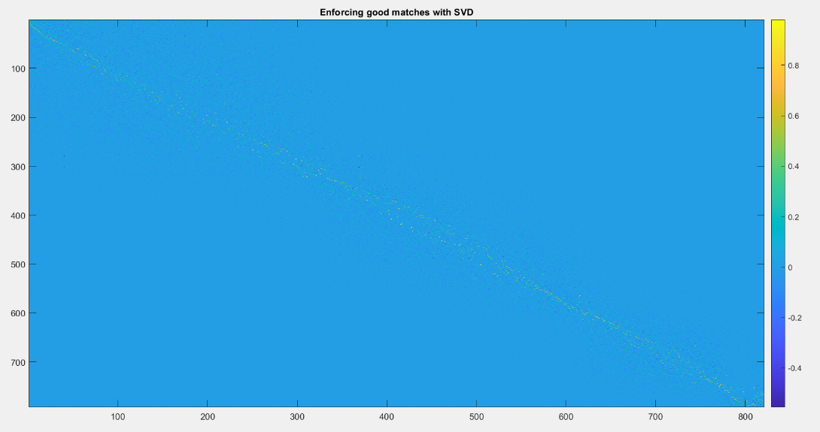
(2d)
By using the SVD method, the matrix can be less affected by noise and an enhancement of the coherent relations between rows and columns is performed. As a result, a yellow-coloured thin diagonal line can be seen in the matrix image. Considering the few detected points (compared to all the pixels of the image) it can be observed that on the diagonal there are strong matches, while everywhere else there are weak matches.
Then the matches found on the two original images can be seen in fig. 2e:

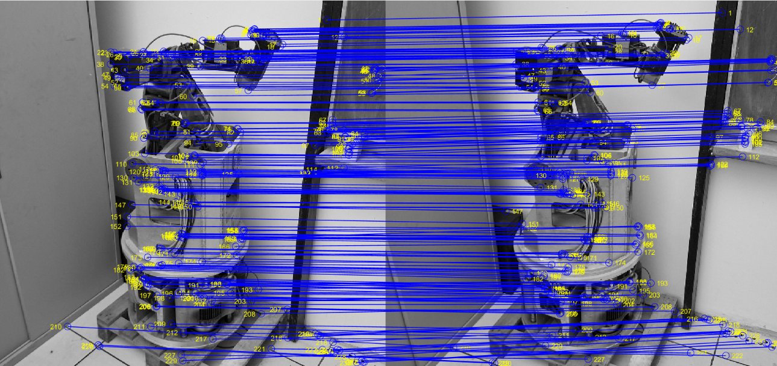
(2e)
Here it can be seen a connection between found matches on both images by considering the candidate points previously taken into account. It can be observed that the match connection lines are almost all horizontal: this means that the y axis coordinates of the matched points are very similar and so the variation between the two images is almost only horizontal. There is a great amount of lines, so it can be considered that there is a good match coherence (stable match) (for example, crossed or oblique lines could be a matching error), the SVD strengthened the correspondences and that the threshold value of 0.65 isn’t that restrictive. So, even if the number of detected matches is large, there is a great probability that the majority of them is correct.

Finally, the last image comparison to show the detected similarity is represented in fig. 2f:

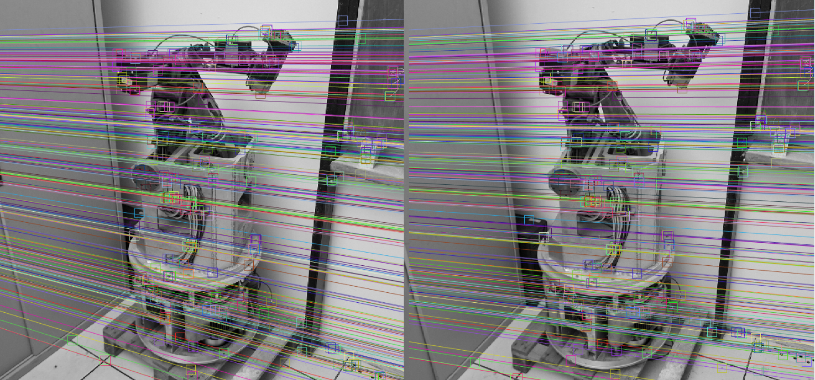
(2f)
This image shows the final result of the feature-matching process between the two robot images. The two views are placed side by side, with detected keypoints highlighted and connected by colored lines. Each line represents a correspondence found between a point in the first image and its match in the second. The large number of nearly horizontal, parallel lines indicates that the two images differ mainly by a horizontal translation, with no significant rotation or geometric distortion. Overall, the visualization demonstrates that the matching algorithm successfully identified many consistent point correspondences between the two views of the robot.

- Eight points algorithm implementation:
For this part of the assignment (involving the “Rubik1.pgm” and “Rubik2.pgm” images) it was asked to define 2 functions EightPointsAlgorithm and EightPointsAlgorithmN regarding the not-normalized and normalized versions of the matrix A in the algorithm.

Normally, The non-normalized Eight Points Algorithm does not apply any normalization to the point coordinates before estimating the fundamental matrix F. As a consequence, it becomes highly sensitive to noise and numerical instability. When point coordinates differ significantly in scale, the estimation of F can be distorted, leading to inaccurate results. The algorithm may also produce epipolar lines that are poorly aligned with the corresponding points and can even violate the rank-2 constraint (although this is typically enforced afterward).
In practice, this results in epipolar lines that appear less consistent, more dispersed, and less faithful to the actual geometric correspondences between the two images.

3.1) Normalized eight points algorithm

An example of this application can be seen on the following images (fig. 3a, fig. 3b):

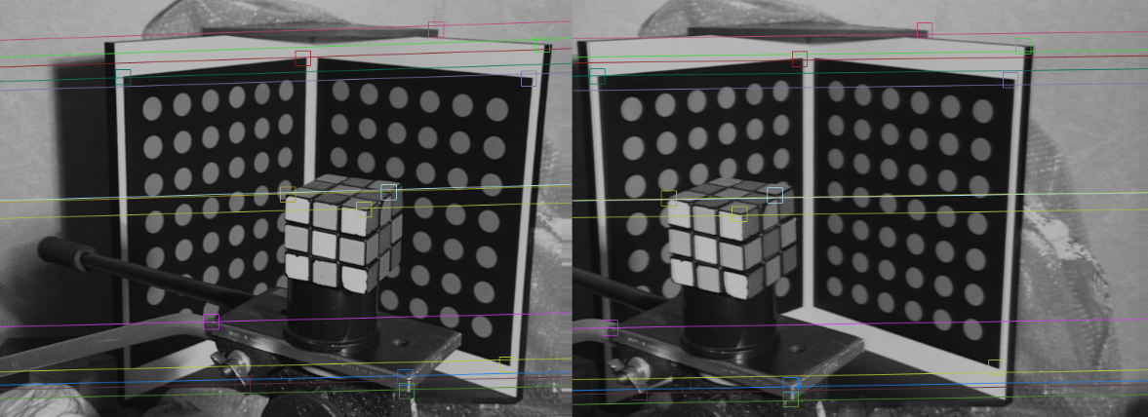

(3a)
This image is the one corresponding to the application of the normalized algorithm. The matrix values are the following:

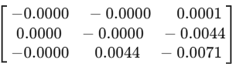
Fn =
The matrix Fn, obtained using the normalized Eight-Point Algorithm, contains small and numerically consistent values. This is expected, since the normalization step rescales the point coordinates, leading to a well-conditioned estimation of the fundamental matrix. As a result, Fn produces stable and accurate epipolar lines.

3.2) Normal eight points algorithm

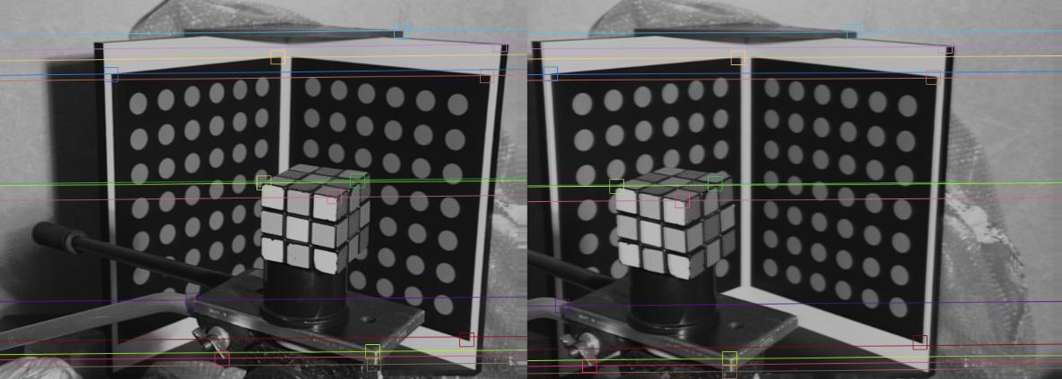

(3b)

Instead, this image shows the application effects of the EightPointsAlgorithm without normalization. The values of the F matrix are the following:

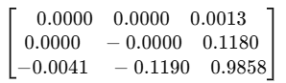
F =

Here the matrix F, computed with the non-normalized Eight-Point Algorithm, exhibits coefficients that differ significantly in scale—ranging from very small values to values close to one. This reflects numerical instability caused by the absence of normalization, especially when the original point coordinates vary widely in magnitude. Consequently, the corresponding epipolar lines are less coherent and more sensitive to noise.

Considering the computation of the left and right epipoles (scaled by a factor of ${10}^{4}$):

- For the F case: e_left = [ 9.1312 ; -0.1032 ; 0.0001]
e_right = [-4.4521 ; 0.1543 ; 0.0001]

- For the Fn case: e_left = [9.4202 ; 0.1583 ; 0.0010]
e_right = [1.1439 ; 0.0108; 0.0001]

The epipoles estimated from the non-normalized Eight-Point Algorithm (F) have extremely large coordinates, indicating that the solution is numerically unstable. This reflects the poor conditioning of F and explains the irregular behaviour of the corresponding epipolar lines.
In contrast, the epipoles obtained with the normalized algorithm (Fn) are significantly more stable and consistent in scale, confirming the benefits of point normalization. In both cases the epipoles lie far outside the image, which is coherent with the stereo configuration: the two camera views are nearly parallel, leading to epipolar lines that are almost parallel and epipoles located at infinity.

Lastly, the check for the epipolar constraint has been done considering the fact that the condition x'^{T}Fx = 0 should be respected. It is respected for both the F and the Fn.

3.3) RANSAC method

Then the RANSAC method has been used on the same image. Here are shown three different versions of the same image (fig. 3c, 3d, 3e):

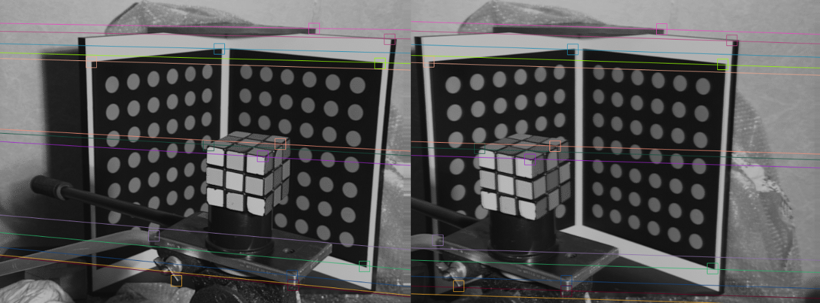

(3c)
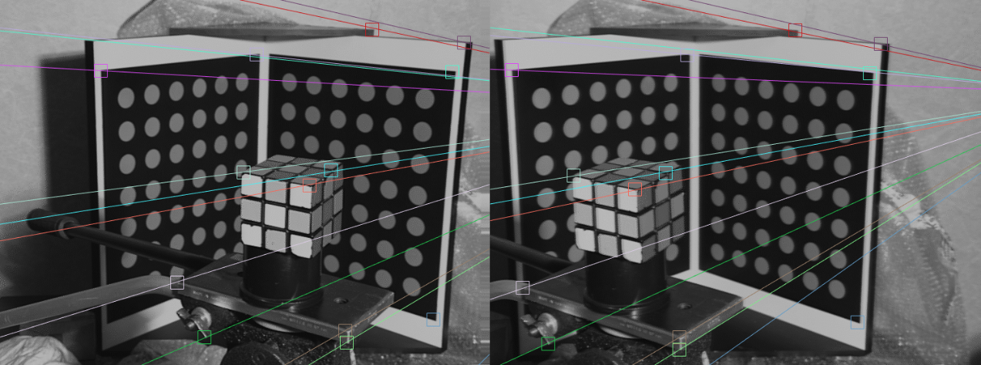
(3d)
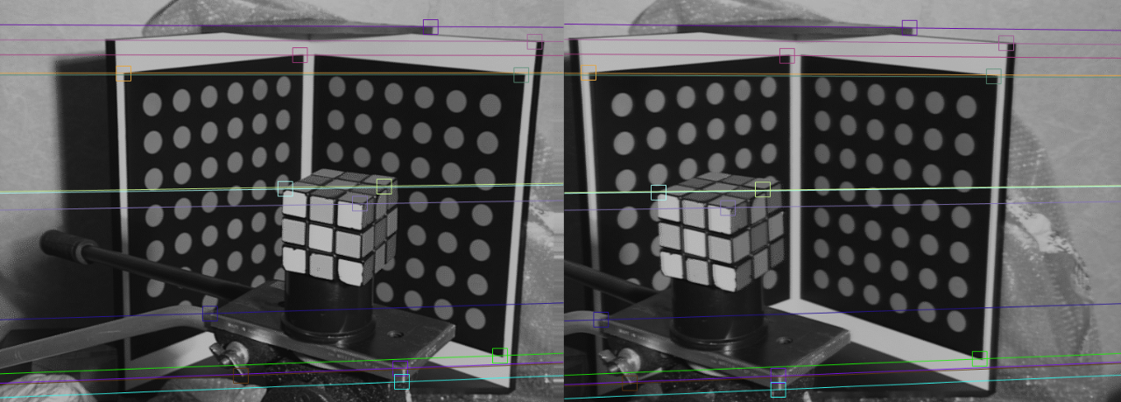
(3e)
The displayed image in fig. 3c and 3e show epipolar lines that are vertical and parallel, indicating that the epipole is positioned outside the image frame. This configuration confirms that the cameras were aligned at the same height, with a slight horizontal rotation and translation. This alignment is appropriate for stereo configurations where the projection centers of the cameras do not visually intersect, yet their fields of view intersect geometrically.
However, results are not consistent across repeated tests. In some instances, we observed epipolar lines that were more inclined (like in fig. 3d). These variations, typical of the algorithm, arise from the randomness in selecting points for each iteration, influencing the sample's representativeness and, consequently, the reliability of the estimated model.
These fluctuations highlight the importance of selecting appropriate parameters and iteration numbers to minimize result discrepancies and ensure a more stable and accurate fundamental matrix estimation.

